Japanese Lesson 7: Word Order

English is a “Subject Verb Object” language. That’s often abbreviated as “SVO.” “SVO” describes the order of words in the sentence. Take the following sentence:
“The cat eats the fish.”
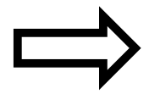 |  | 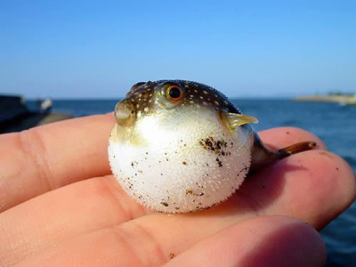
The cat | eats | the fish.
Subject | Verb | Object
Doer of the action | Action | Receiver of the action

If we reverse the order of the words to be “the fish eats the cat,” the sentence has the opposite meaning. This is because English uses the verb to separate the subject and object in the sentence, and to indicate who does the action:
The fish | eats | the cat.
Subject | Verb | Object
Doer of the action | Action | Receiver of the action

Japanese is a “Subject Object Verb” language, or “SOV” language. The same sentence:
 | 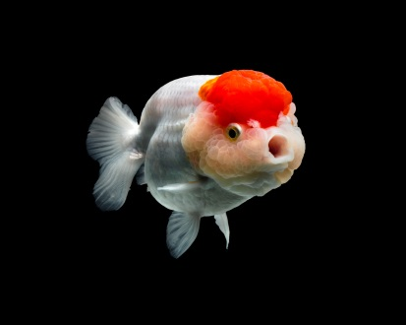
ねこは | さかなを | たべます.
The cat | fish | eats.
Subject | Object | Verb
Doer of the action | Receiver of the action | Action
Note that the verb comes at the end of the sentence. This is how all Japanese sentences are structured – the verb is always at the end of the sentence.
But you may notice that we have a problem. When we say “the cat fish eats” in Japanese, how do we know whether we mean this:

 | 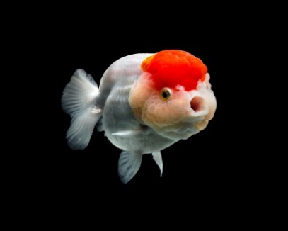
The cat | fish | eats

Versus this?
The catfish | eats

The “particles” shown in bold (“wa” and “wo”) in the Japanese sentence solve this problem. They tell us exactly who is doing what.
To recap: English uses a verb to separate the doer of the action and the receiver of the action. Because Japanese places all of its verbs at the end of its sentences, it can’t use verbs as separators like that. And it would be very confusing to have a jumble of nouns all together without knowing where one started and one ended – like in the example sentence “cat fish ate.” So instead, Japanese uses these “particles”, small syllables that attach at the end of a word, to indicate who is the doer of the action and who is the receiver of the action.
- “wa”, as in “neko wa.” This is the “subject particle.” It tells us who does the action.
- “wo”, as in “sakana wo” This is the “direct object particle.” It tells us who receives the action.
- “ka”, that we use in sentences like “wakarimasu ka?” This is the “question particle. It tells us that that we’re asking something.

Also note that, like in our final sentence, not every sentence needs a “wo” particle. Use only as many particles as you need for clarity. “Neko wa tabemasu” is a good sentence that simply means “The cat ate.”

